

**Company Contact**

Jl. AMD Babakan Pocis No. 88h RT04/02, Kel. Bakti Jaya,Kec. Setu, Kota. Tangerang Selatan, Banten, Indonesia. Kode Pos 15315.

**Email**: hakohoodie1@gmail.com

**Phone:** +62 878 0867 5313

**Website:** <https://hako-hoodie.github.io>

**BUSINESS PROPOSAL**

PT Hako Hoodie

# **TABLE OF CONTENTS**

**INTRODUCTION 3**

**PURPOSE 3**

**BACKGROUND 4**

**BUSINESS OPERATIONS 4**

**PRODUCT 5**

**MARKETING STRATEGY 6**

**INVESTMENT CAPITAL 6**

**MONTHLY INCOME 7**

**CONCLUSION 7**

**TERMS AND CONDITIONS 8**

**AGREEMENT 8**

# **INTRODUCTION**

The history of the establishment of PT Hako Hoodie began on June 28, 2020. This company was started by Andri Firman Saputra as the current president director. PT Hako Hoodie is a leading hoodie provider for businesses in apparel. With a team of experts who have extensive experience in their fields, we are well positioned to help our clients grow and thrive, even in challenging times. By truly knowing our customers, our talented team can offer unique and customized solutions backed by data-driven analysis and extensive research.

As a company, we believe in building long-term client partnerships that help us all grow. To learn more about how our tailor-made hoodie solutions can help your business thrive, read on. Putting a smile on a customer's face is everything to us.

# **PURPOSE**

For now, PT Hako Hoodie plans to increase the number of productions to be faster by recruiting designers and trying to penetrate the market by opening several new stores to increase sales turnover. for this development, PT Hako Hoodie requires additional funds/capital, so by making this proposal it is intended to apply for additional capital financing of Rp. 500,000,000, - (five hundred million rupiah) to add 1 shophouse, recruit designers and other equipment.

# **BACKGROUND**

The history of PT Hako Hoodie began on June 28, 2020. The company was founded by Andri Firman Saputra as the current president director. At first, production was only on a shop scale but using quality raw materials and was comfortable to use. in 2020, PT Hako Hoodie was appointed to an office in South Tangerang, Banten. although this is a new company in the field of clothing, we are more focused on making hoodies. PT Hako Hoodie is optimistic about the priority of service and comfort for the people of Indonesia and ensures that the quality of our products is guaranteed. the presence of PT Hako Hoodie as a new company in Indonesia is committed to serving the needs of the community. PT Hako Hoodie is ready to serve Indonesia to maintain product feasibility and reliability. we will continue to develop product innovation. then, PT Hako Hoodie has a brand under the name Hako Hoodie. Hako Hoodie products focus on making hoodies with the best quality for consumer needs at low prices with maximum quality.

# **BUSINESS OPERATIONS**

The material we use in our Hako Hoodie products is polar fabric with the best quality. This material uses a blend of cotton and wool, making it stretchy and very comfortable to wear. We use quality raw materials and process them as well as possible to produce a quality and comfortable hoodie.

# **PRODUCT**

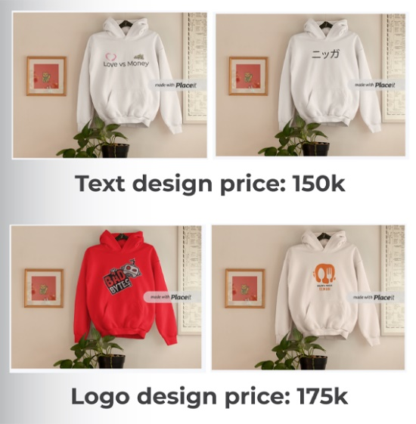

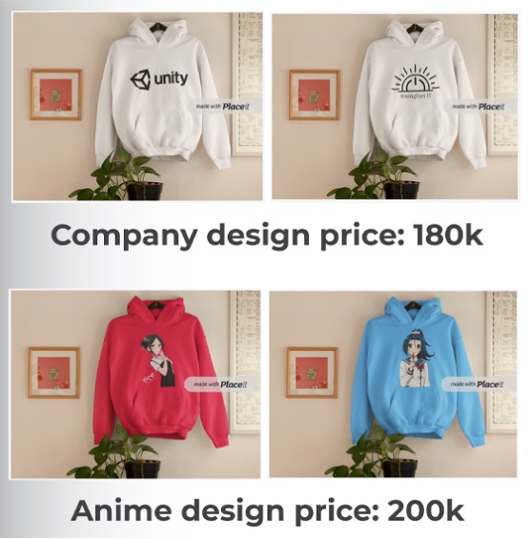

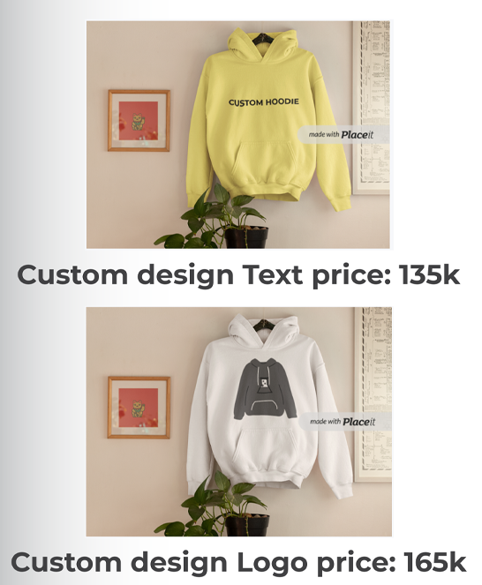

# **MARKETING STRATEGY**

For our marketing strategy, we always prioritize product quality and consistency in the raw materials we use, so that product comfort is maintained so that consumers are satisfied with our products. Not only that, Hako Hoodie products have many design variants, so consumers have many choices according to their wishes.

Currently, Hako Hoodie products have 2 offline stores spread across the South Tangerang Region, and not only that, to increase our sales turnover, we shop online on several digital platforms, and have our own website for product sales.

# **INVESTMENT CAPITAL**

|  |  |  |  |  |
| --- | --- | --- | --- | --- |
| **No.** | **Particulars** | **Qty** | **Price** | **Total Price** |
| 1 | Store | 1 | Rp 300.000.000 | Rp 300.000.000 |
| 2 | Desainer | 5 | Rp 5.000.000 | Rp 25.000.000 |
| 3 | Computer Set | 5 | Rp 20.000.000 | Rp 100.000.000 |
| 4 | Table | 10 | Rp 500.000 | Rp 5.000.000 |
| 5 | Chair | 10 | Rp 600.000 | Rp 6.000.000 |
| 6 | Renovation | 1 | Rp 20.000.000 | Rp 20.000.000 |
| 7 | WiFi | 1 | Rp 800.000 | Rp 800.000 |
| 8 | Printer | 1 | Rp 3.000.000 | Rp 3.000.000 |
| 9 | AC | 5 | Rp 4.000.000 | Rp 20.000.000 |
| 10 | Cleaning Tool | 1 | Rp 1.000.000 | Rp 1.000.000 |
| **Total** | | | | **Rp 480.800.000** |

# **MONTHLY INCOME**

|  |  |  |  |  |
| --- | --- | --- | --- | --- |
| **No.** | **Products** | **Qty** | **Price** | **Total Price** |
| 1 | Hoodie with Text Design | 140 | Rp 150.000 | Rp 21.000.000 |
| 2 | Hoodie with Logo Design | 254 | Rp 175.000 | Rp 44.450.000 |
| 3 | Hoodie with Company Design | 122 | Rp 180.000 | Rp 21.960.000 |
| 4 | Hoodie with Anime Design | 303 | Rp 200.000 | Rp 60.600.000 |
| 5 | Hoodie with Custom Text Design | 174 | Rp 135.000 | Rp 23.490.000 |
| 6 | Hoodie with Custom Logo Design | 293 | Rp 165.000 | Rp 48.345.000 |
| **Total** | | | | **Rp 219.845.000** |

# **CONCLUSION**

Investment is the activity of investing money or capital (valuable assets) for the purpose of obtaining profits related to finance and the economy. This term relates to the accumulation of some form of asset in the hope of earning a profit in the future. We will give you 20% of our sales revenue every month for 1 year. In our investment proposal, we hope that this investment proposal can be accepted, we realize that there are still many shortcomings in the writing of this proposal, therefore constructive criticism and suggestions are needed from various parties.

# **TERMS AND CONDITIONS**

This hoodie Business Proposal Contract outlines the terms and conditions that govern the contractual agreement between PT Hako Hoodie and PT Bank Central Asia Tbk. Both PT Hako Hoodie and PT Bank Central Asia Tbk agree to be bound by the terms laid out in this Business Proposal Contract.

whereas, the Seller agrees to deliver hoodie

whereas, the Purchaser agrees to purchase hoodie according to the terms and conditions laid out in this contract.

Therefore, in consideration of the mutual agreement made by the parties hereto, the Seller and the Purchaser agree to the following:

* Willing to pay a fine if you don't follow the requirements
* Accept the reality if the business fails in the end result
* Work together effectively and wisely

# **AGREEMENT**

In signing this document below, Andri Firman Saputra and Harjasa Firmansyah confirm their agreement to the terms and conditions laid out in this business proposal and form a binding contractual agreement beginning on the date of signing.

PT Hako Hoodie PT Bank Central Asia Tbk

 

07/15/2022 07/25/2022  
Andri Firman Saputra Harjasa Firmansyah